Customer Churn Prediction and Revenue Impact
Analysis Using Machine Learning

Hudson Merritt
ISAN 3392
Dr. Fred Zhao
May 5, 2026

Table of Contents
Project Description ……………………………………………………………………………3
Data Exploration and Preprocessing ………………………………………………………..3-5
Models and Algorithms …………………………………………………………………….6-7
Results and Discussion ……………………………………………………………………..7-8
Summary ……………………………………………………………………………………...8

1. Project Description
Customer churn is a major concern for subscription-based businesses, particularly in the telecommunications industry. When customers discontinue their service, companies not only lose recurring revenue but also incur additional costs associated with acquiring new customers. As competition increases, retaining existing customers becomes just as important as acquiring new ones.
The purpose of this project is to develop machine learning models that predict customer churn and estimate the financial impact associated with it. While many organizations use predictive analytics to identify customers likely to leave, fewer incorporate a financial perspective to quantify the potential revenue loss. This project aims to bridge that gap by combining predictive modeling with revenue analysis.
The primary objectives of this project are to predict which customers are likely to churn, identify the key factors influencing customer churn, estimate the total revenue at risk due to churn, and provide actionable business insights to improve customer retention strategies. By achieving these objectives, the project demonstrates how machine learning can be applied to support data-driven decision-making in a business context.
2. Data Exploration and Preprocessing
The dataset used in this project is the Telco Customer Churn dataset, which contains customer-level information such as demographics, service usage, and billing details. The dataset includes variables such as gender, senior citizen status, contract type, tenure, monthly charges, total charges, and whether the customer churned.
The target variable in this project is Churn, which indicates whether a customer has left the company. This variable was converted into a binary format where 1 represents a customer who churned and 0 represents a customer who remained.
The predictor variables include customer demographics, account information, service usage features, and financial variables such as monthly charges and total charges. These variables are used to predict the likelihood of churn.
Initial data exploration was performed to understand the structure and quality of the dataset. Summary statistics and data types were reviewed, and missing values were identified. The variable TotalCharges contained missing or improperly formatted values, which were converted to numeric format and imputed using the median value to ensure data consistency.
Categorical variables such as contract type, payment method, and internet service were converted into dummy variables using one-hot encoding. This transformation allows machine learning models to interpret categorical data effectively.
To incorporate a financial perspective, a new variable called Estimated Revenue Loss was created by multiplying monthly charges by an assumed six-month period. This variable represents the potential future revenue lost if a customer churns.
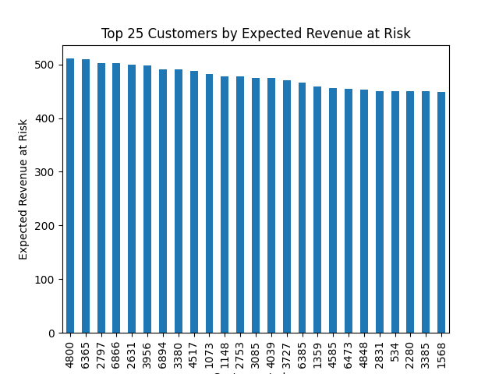
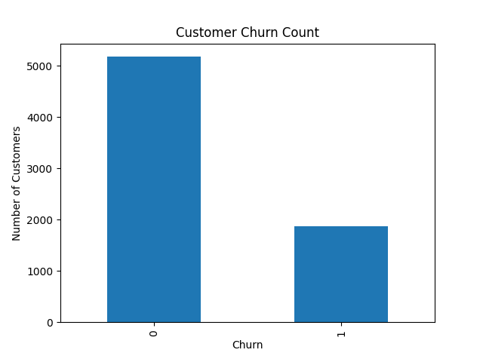
Several visualizations were created to explore patterns in the data. For example, a bar chart of churn distribution showed the proportion of customers who left versus those who stayed (right). Additional visualizations highlighted differences in churn rates across contract types (not pictured) and the top 25 customers by their expected risk of revenue (right). These exploratory analyses provided initial insights into the factors influencing churn and visualized overall financial analysis.
The dataset was then partitioned into training and validation sets using a 60/40 split. Stratified sampling was used to maintain the original distribution of the churn variable. Additionally, feature scaling was applied to the training and validation data for models that require normalized inputs, such as logistic regression and neural networks.

3. Models and Algorithms
To best analyze our data, multiple machine learning models were implemented to predict customer churn.
The first model used was logistic regression, which serves as a baseline model. Logistic regression is widely used for classification problems and provides interpretable results by estimating the probability of churn based on input variables.
The second model was a decision tree classifier, which identifies decision rules that segment customers based on their likelihood of churn. Decision trees are useful for understanding relationships between variables and provide clear insights into decision-making processes.
The third model was a neural network, specifically a multi-layer perceptron. This model captures complex, non-linear relationships in the data and can improve predictive performance compared to simpler models.
An ensemble model, specifically a random forest classifier, was also implemented. Random forest combines multiple decision trees to improve accuracy and reduce overfitting. This model was tuned using grid search to optimize parameters such as the number of trees, maximum depth, and minimum samples per leaf.
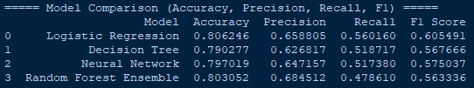
Model performance was evaluated using several metrics, including accuracy, precision, recall, and F1 score. Recall was particularly important in this context, as failing to identify a customer who is likely to churn can result in lost revenue.
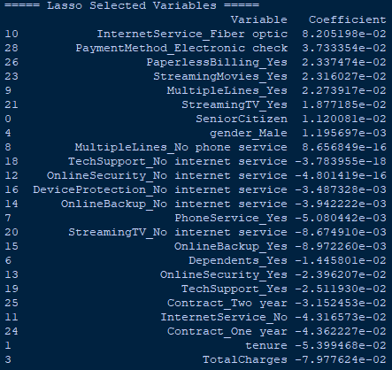
In addition, Lasso regression was used as a variable selection technique. Lasso helps identify the most important predictors by shrinking less significant coefficients to zero, thereby simplifying the model and improving interpretability.
4. Results and Discussion
The models were evaluated using accuracy, precision, recall, and F1 score to determine how effectively they identify customers at risk of churning. While all models performed similarly, the focus of this analysis was on how the results can support better business decisions rather than purely technical performance.
Logistic regression achieved the highest recall (56.0%), meaning it identified the largest number of customers who actually churned. This is important because missing at-risk customers can lead to lost revenue. On the other hand, the random forest model had the highest precision (68.5%), indicating that when it predicts a customer will churn, it is more likely to be correct. This makes it useful for targeting retention efforts more efficiently and avoiding unnecessary costs.
From a business perspective, both models provide value. Logistic regression is useful for broadly identifying customers at risk, while random forest helps prioritize the most reliable cases for targeted action. Together, they provide a balanced approach to customer retention.
The analysis also showed that contract type, tenure, and monthly charges are key drivers of churn. Customers with month-to-month contracts and shorter tenure were more likely to leave.
To add a financial perspective, customers were ranked based on expected revenue loss. The results showed that a small percentage of customers accounted for a large portion of total revenue at risk. This suggests that businesses should focus retention efforts on high-risk, high-value customers rather than applying broad strategies.
Overall, the results demonstrate that the true value of the models lies in their ability to provide actionable business insights. By identifying both who is likely to churn and the financial impact of that churn, companies can make more informed decisions to reduce customer loss and improve profitability.
5. Summary
This project demonstrates how machine learning can be applied to solve a real-world business problem by predicting customer churn and estimating its financial impact. The results show that machine learning models can effectively identify customers at risk of churning and provide valuable insights into the factors driving customer behavior. By incorporating financial analysis, the project goes beyond prediction and quantifies the potential revenue impact of churn.
This project taught me the importance of data preprocessing, model selection, and evaluation metrics in building effective machine learning solutions. Additionally, the integration of financial analysis highlights the value of translating technical results into actionable business insights.

